**FPOM Workgroup Meeting: McNary Dam Falconry in 2024**

9 February 2023, 1 pm.

Conference line: 1-844-800-2712 Access: 199 076 9084

WebEx meeting:

<https://usace1.webex.com/usace1/j.php?MTID=mfd2225aec54960151ed1beffdc99906a>

Access Code: 199 076 9084 Password: fy21FPOM**

Background: Currently hazing by USDA (land and boat-based) is used to deter avian predation of juvenile salmonids during peak of juvenile outmigration at McNary Dam. The Corps and Region would like to explore use of falconry as method to reduce avian predation. Funding does not allow both methods to be used at the same time.

Goal: To investigate if we can develop an acceptable plan where falconry could be used to deter avian predators at McNary Dam in place of bird hazing in 2024.

Current bird abundances

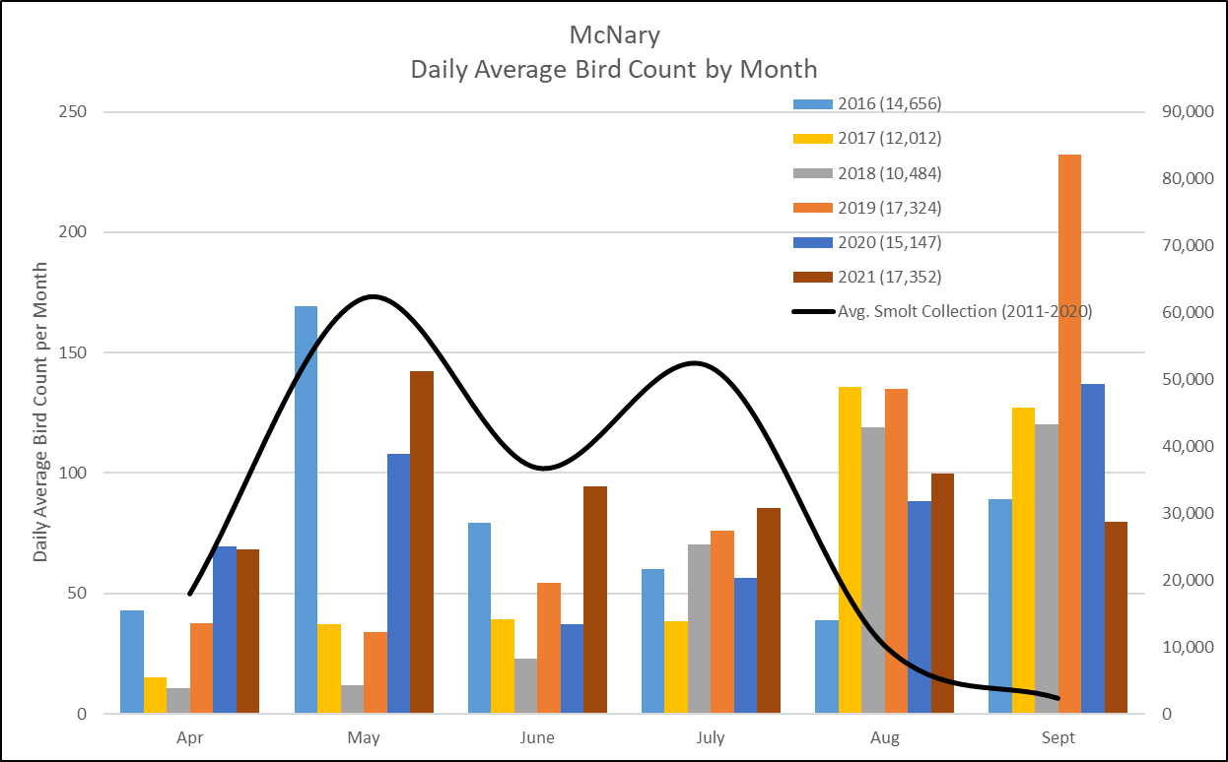

USDA hazing effort

Land-based: April 23 – July 22, 2023, (91 d)

12 hrs per day Monday-Saturday, 8 hrs per day Sunday

Work between 0700 and 2100 hours; Actual hrs worked can vary per bird abundances

Boat-based: April 30 - July 8, 2023, (10 weeks or 30 days)

3 days per week, 10 hrs per day, Monday-Saturday

Work between 0600 and 2100 hours; start time can vary per bird abundances

Potential Falconry Schedule

Late April through July?